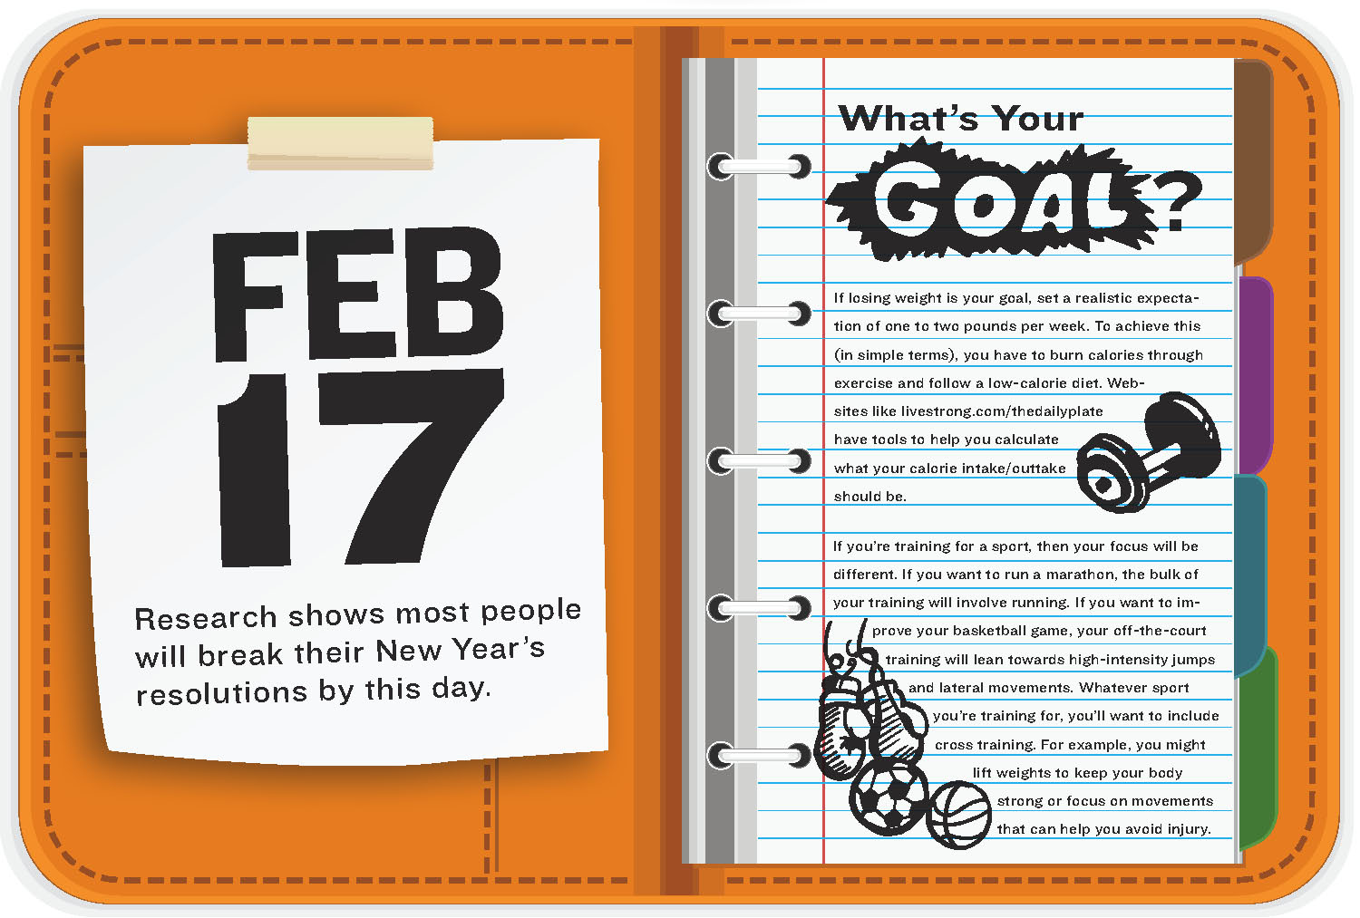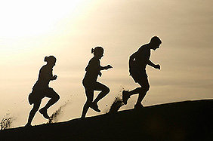

**[Your Name]**

[Height & weight]

[Pre-Fitness Score Push Up]

[Pre-Fitness Score Curl Up]

[Pre-Fitness Score Flexibility]

[Pre-Fitness Score Aerobic Capacity]

Review your baseline fitness scores and describe the activities you like to do and the goals you have set.

SMART FITNESS GOALS

* [Describe a short term nutrition goal here]
* [Describe a short term muscular strength goal here]
* [Describe a short term cardiovascular goal here]

Write a positive statement here! Explain what you love to do for fun to get some exercise!

Insert your favorite Cardiovascular Endurance exercise here. Pick an activity you enjoy doing. You can use google images, draw, or take your own photo.

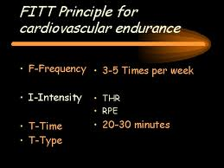

Insert your photo here!

“INSERT A FITNESS QUOTE HERE.”

Insert photo of Muscular Strength here. Pick an activity you enjoy doing. You can use google images, draw, or take your own photo.

Nutrition Plan

Nutrition is important for all around fitness. The foods and drinks we consume play a major part in our overall wellness. If we eat more calories than we burn, then weight gain will happen. But did you know the *types* of food we eat effect how we feel? This means that some foods increase chances of weight gain, but also make us feel like not moving. It is important to eat a high quality diet to help us manage calorie balance **and** make us feel like we want to get up and move, dance, play sports, etc..

:

**Breakfast –** [list 3 of the foods you should eat for this meal.]

**Snack –** [list a food you should eat for this snack]

**Lunch –** [list 3 of the foods you should eat for this meal]

**Snack -** [list a food you should eat for this snack]

**Dinner -** [list 3 of the foods you should eat for this meal]

1. **Muscular Strength/Endurance Overload:** To help you improve [your muscular strength or endurance goal] you will need to increase [describe activity here].
2. **Cardiovascular Fitness Overload:** To help you improve [your cardiovascular fitness goal] you will need to increase [describe activity here].

**OVERLOAD**

Insert photo of a healthy recipe

Insert photo of Flexibility here. Pick an activity you enjoy doing. You can use google images, draw, or take your own photo.

Insert photo of Muscular Endurance here. Pick an activity you enjoy doing. You can use google images, draw, or take your own photo.

**[Choose (1) goal for your you to create a progression):** The best way for me to [describe your goal] I will need to increase the amount of [describe specific exercises prescribed for you aligned with goals] by gradually increasing the number of sets and reps for muscular strength and endurance, or by increasing the time exercising for cardiovascular fitness. The progression plan will be:

* 1. **Week 1 [describe frequency, intensity level, type, and time, of the exercise you are prescribing for you]**
  2. **Week 2 [same as above but increase the load no more than 10% increase from previous week]**

**PROGRESSION**